JOHNNY LIVECAREER

 | (555) 555-5555 | (555) 555-5555 | City, State ZIP Code example@example.com

Professional Summary |  | This type of resume is called a combination or hybrid resume. It features a thorough list of the job seeker's most relevant skills and a job history section to show off your employment experience. Here in the summary section, list in two to three sentences why you're the right person for the job. Emphasize important skills you possess and your best career accomplishments. Remember, this is usually the section hiring managers spend the most time on, so it should be concise and customized to the job posting. For more summary writing tips, see our How to Write a Resume Summary article.

Summary of Qualifications |  | - Written in a bulleted sentence list, this section summarizes your key qualifications.  - This section should contain three to four sentences that set the foundation for either your bulleted list of skills or your Key Skills section.  - The purpose of this section is to show how your transferable skills are utilized in the field.  - Example: “Managed all store operations, including organization, maintenance, and purchasing functions.”  -  Key Skills:  - This section is paired with, and sits directly below, the Summary of Qualifications.  - The resume format you choose will determine the length of this section.  - For a combination resume format, consider a bulleted list with a mix of six to eight hard and soft skills.  - Skills should directly relate to the required qualifications in the job ad and your relevant experience.  - For more information on this section, read How to Write a Resume Skills Section.

Work History |  | POSITION, 07/2017 - Current  Company, Company City, Company State  - Work backward, listing your current or most recent job first.  - Articulate your value to the employer with callbacks to their job posting that emphasizes your key strengths.  - Use numbers (like dollars and percentages) in this section to help employers quickly see the results of your accomplishments.  POSITION, 07/2014 - 07/2017  Company, Company City, Company State  - Highlight skills and tasks that relate to the job you're applying to.  - Show how you have learned from past experiences.  POSITION, 05/2011 - 06/2014  Company, Company City, Company State  - Work backward, listing your current or most recent job first.  - Articulate your value to the employer with callbacks to their job posting that emphasizes your key strengths.  - For more tips on what to include in the work history section, visit our page on crafting a Work Experience Section.

Education |  | Degree Abtained: Field of Study  School Name - City And State Where The School Is Located  Certification or Additional Training: Field of Study

There are multiple ways to lay out your combination resume. Here are four additional options to consider. Each of these resume options can be created by using LiveCareer’s professional Resume Builder.

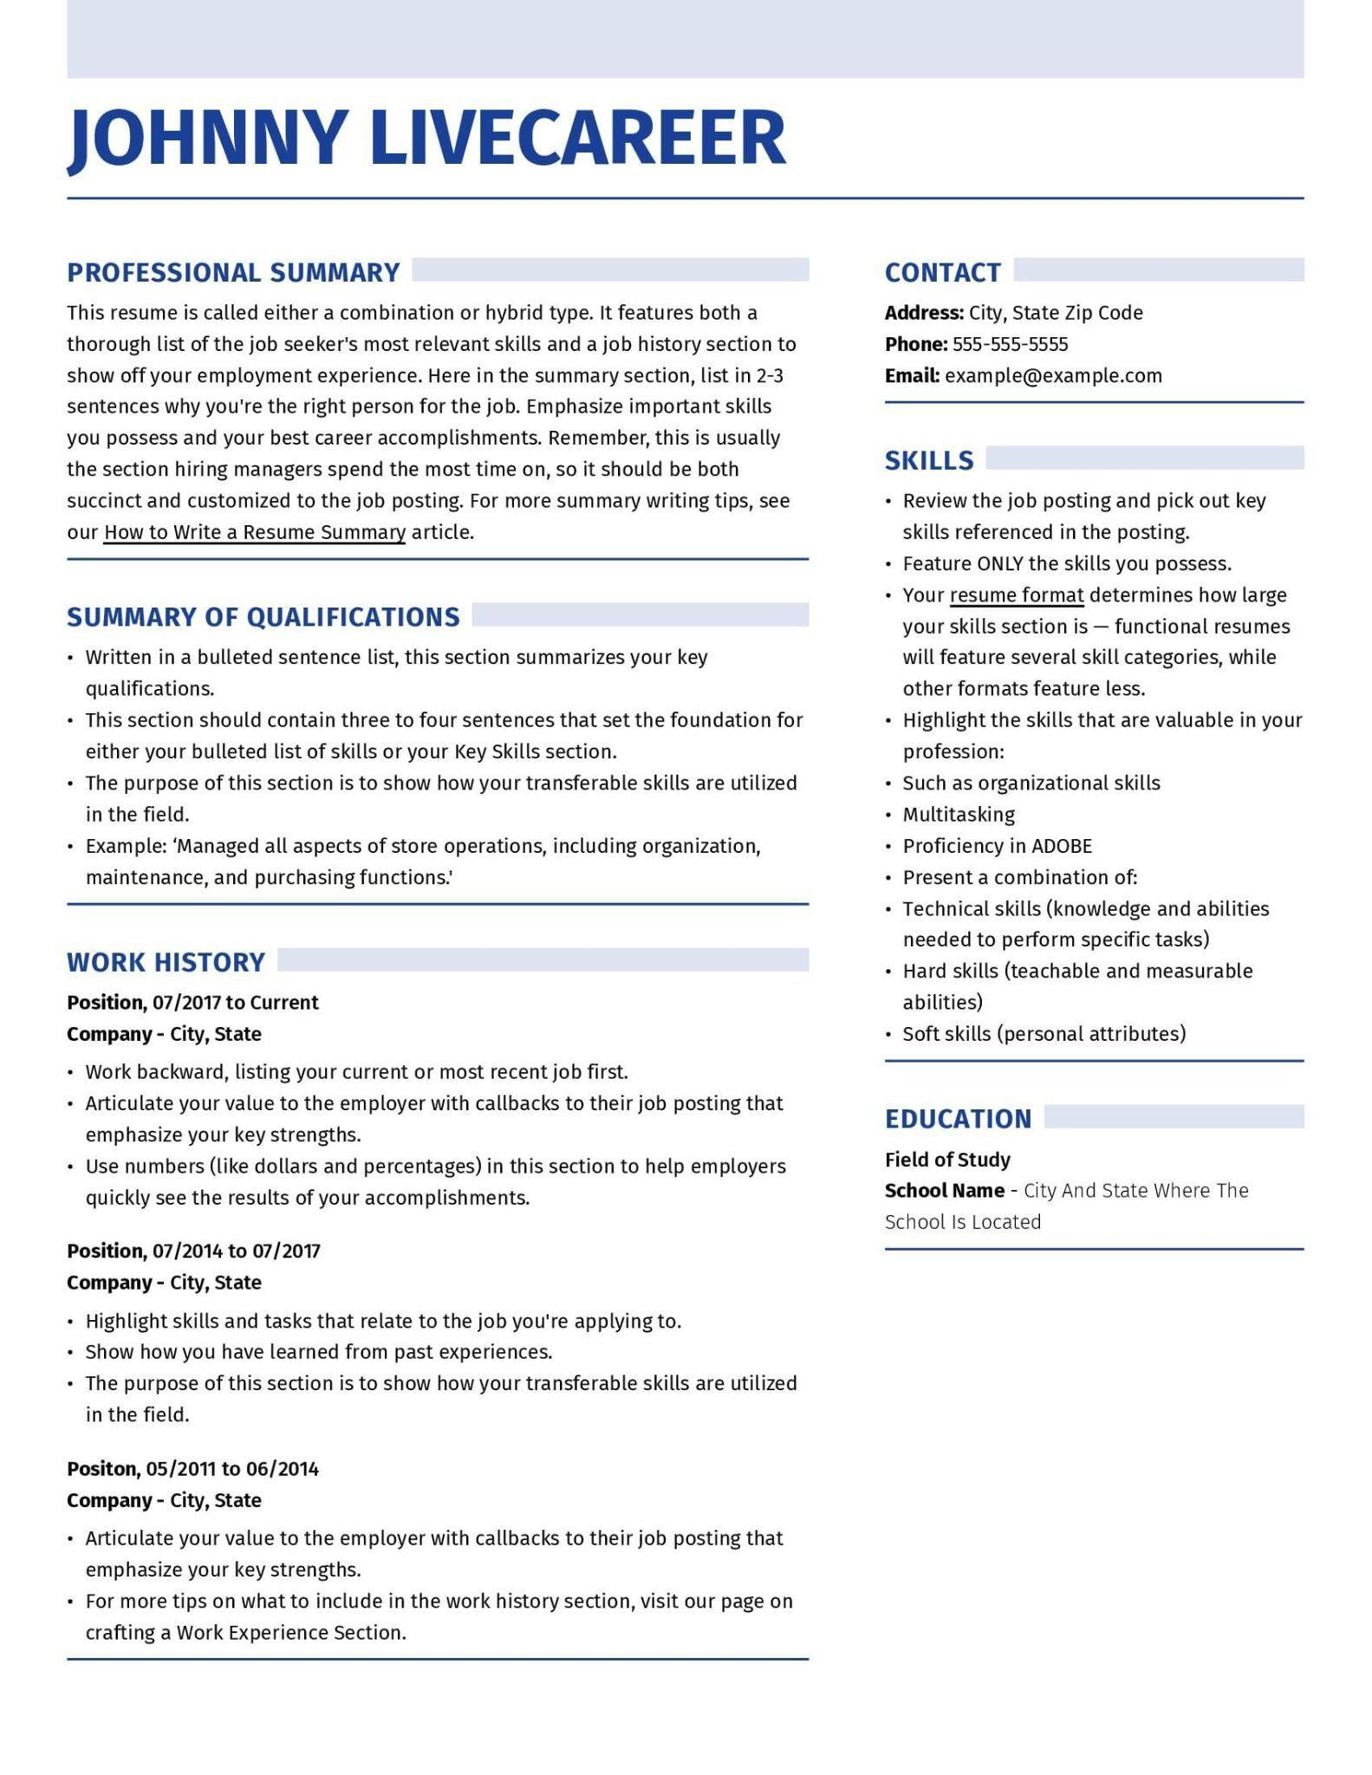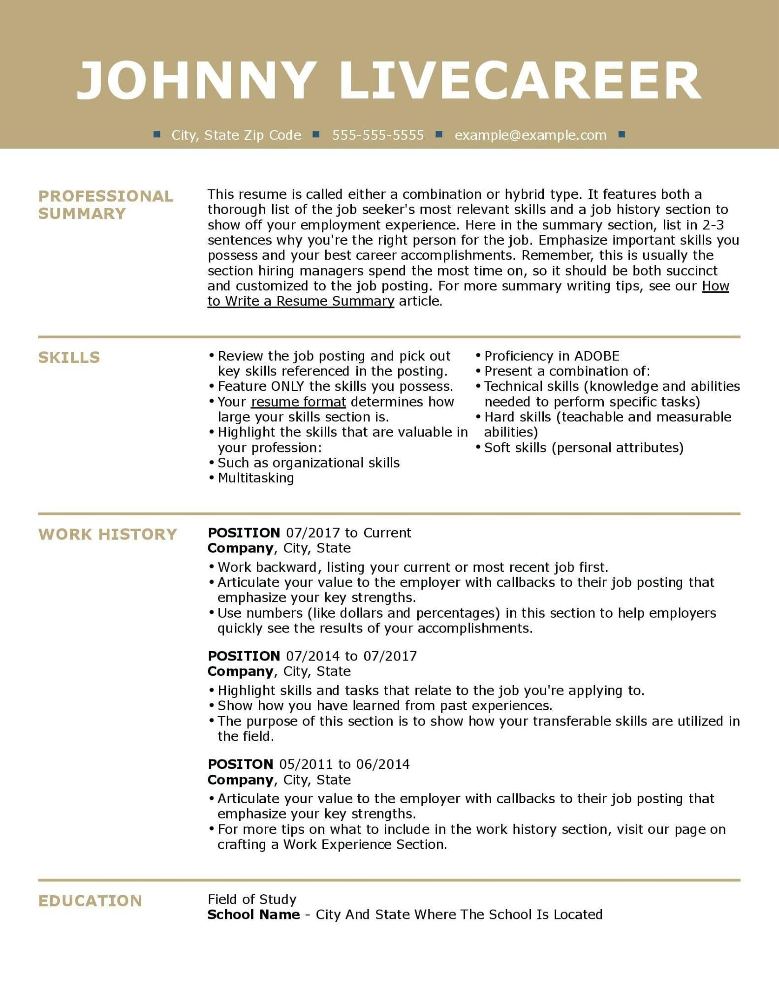
Example 1: Relevant Skills and Professional Skills in the Rail Example 2: Bulleted Skills Above Work History

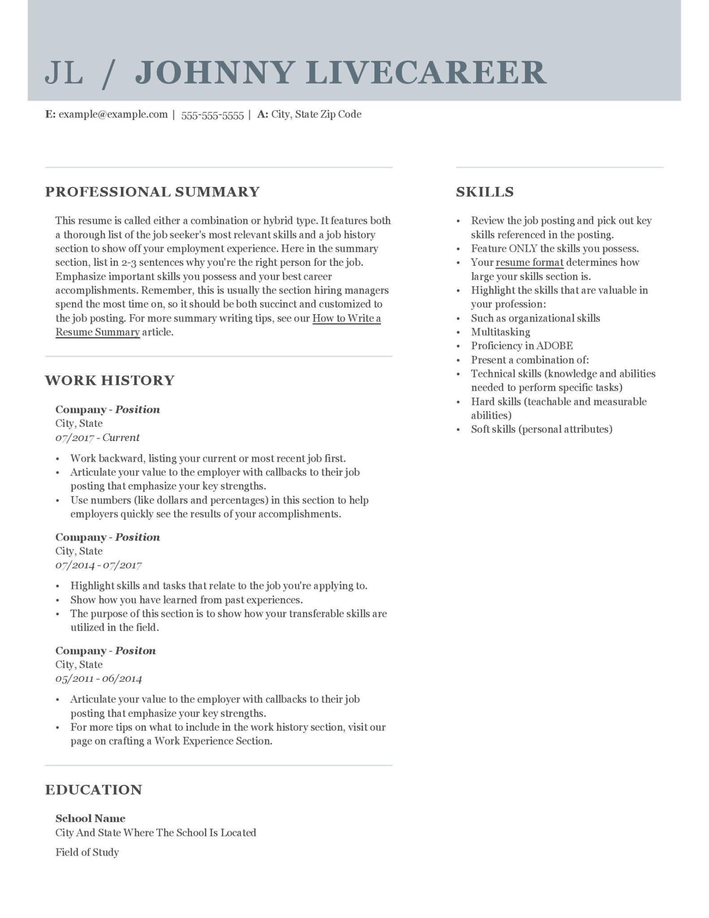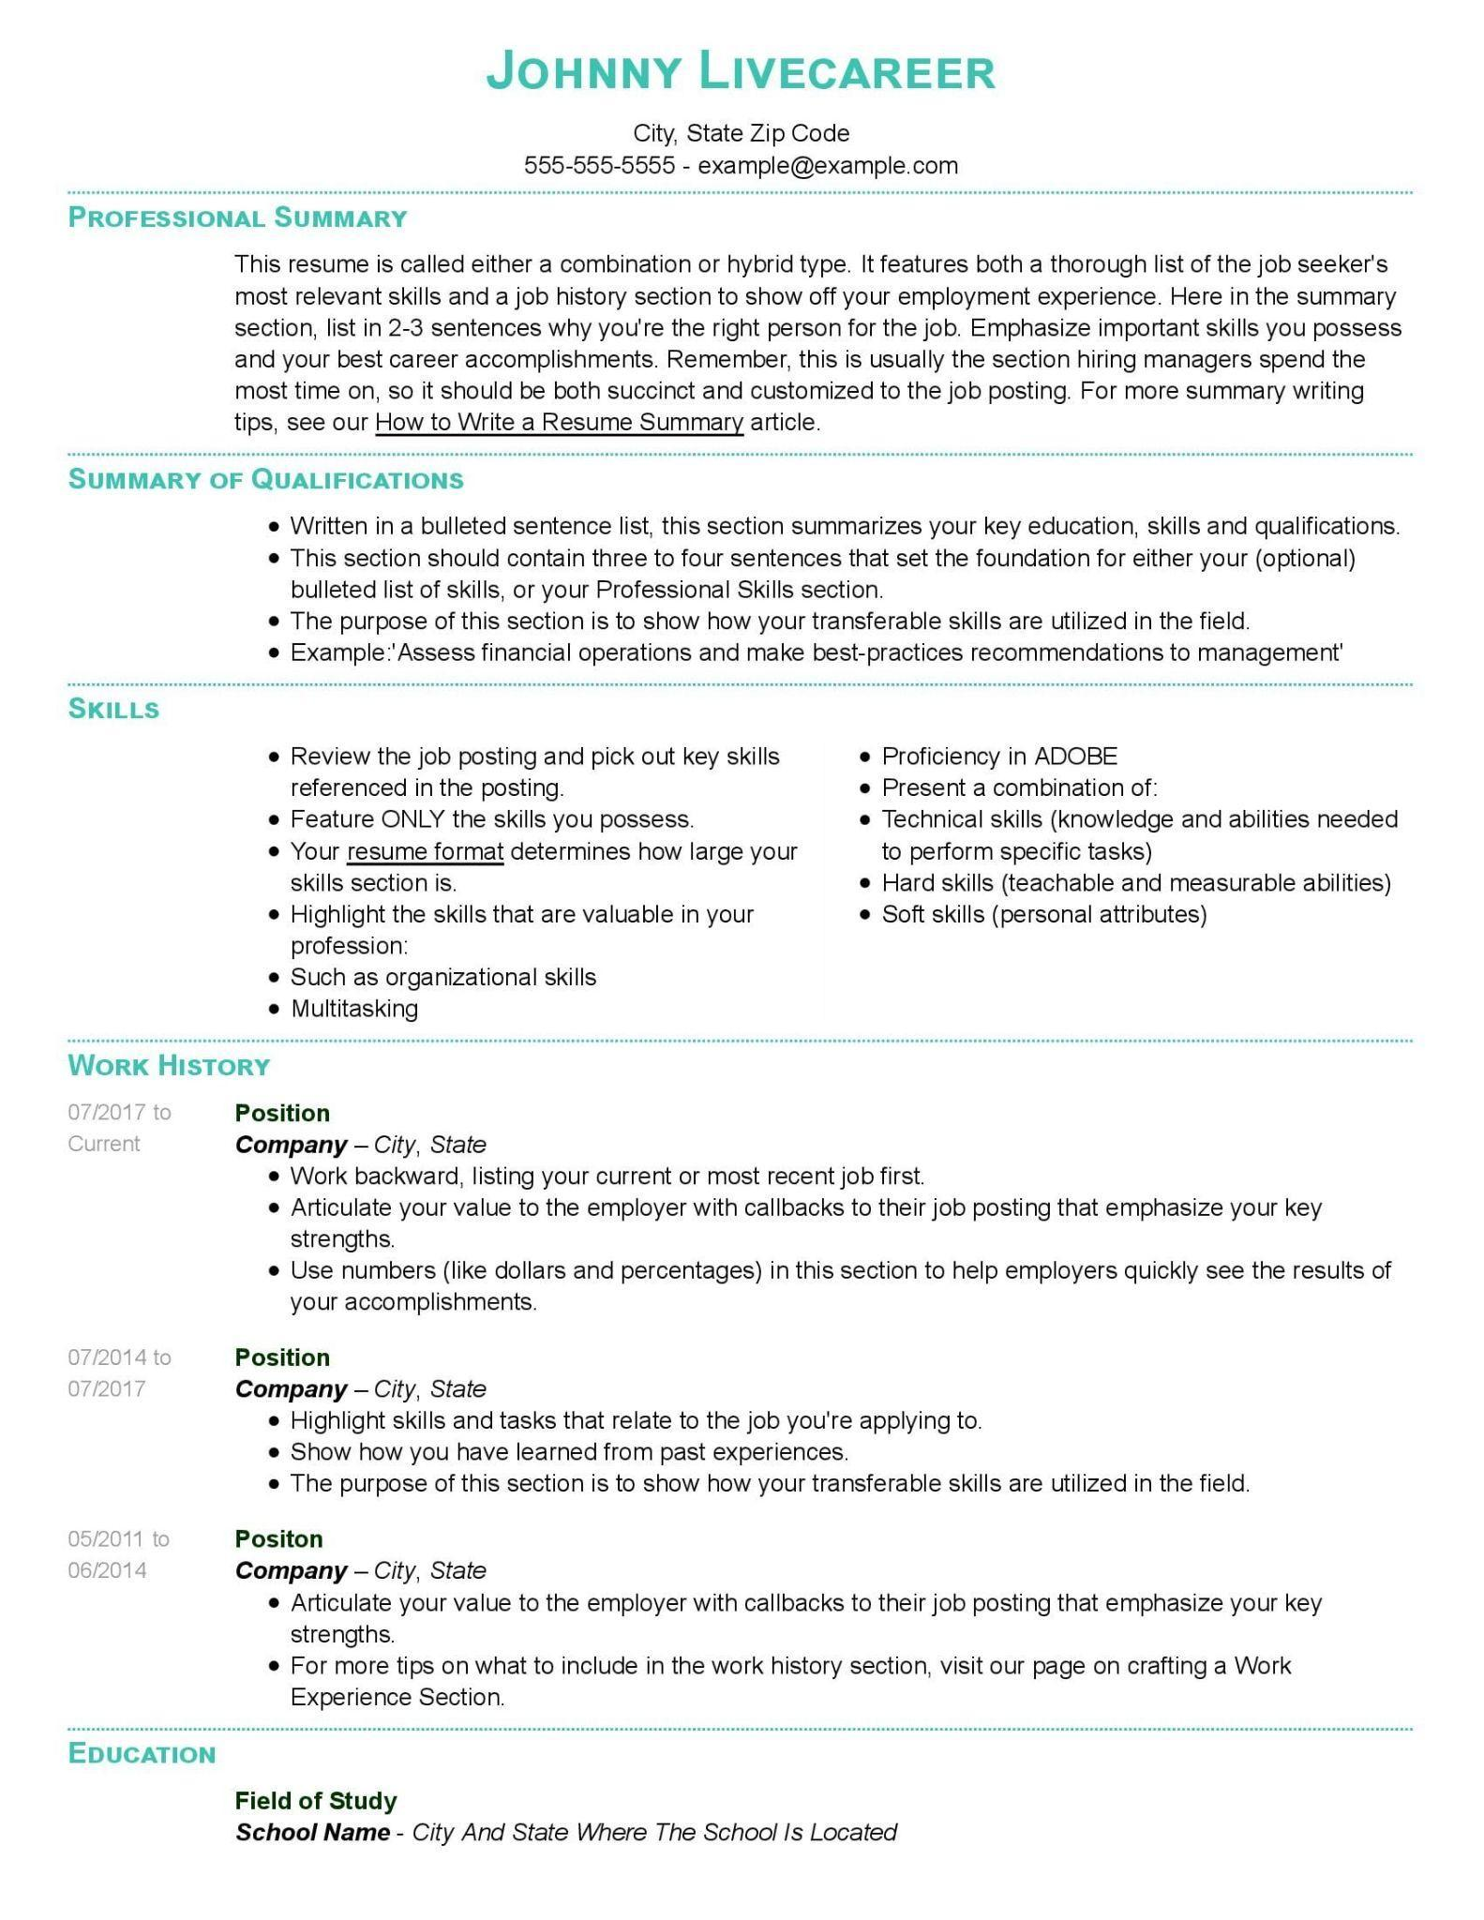
Example 3: Expanded Skills Section in the Rail Example 4: 1 Column All Skill Formats

More tools to help you write your Combination resume:

Is a Combination Resume Right for You?
Here, we outline everything you need to know about combination resume formats to help you decide if it is the right choice for you.

How to Write a Resume
Study this helpful article which lays out how to write every section of your resume in eight simple steps. Learn how to present your qualifications in a way that will capture the attention of recruiters and hiring managers.

Resume Examples for Every Job Title
Customizing your resume to the role you seek is critical to a successful job search. Peruse our library of resume examples written by certified resume writers to see what recruiters look for in top candidates.

Cover Letter Examples
If you’d prefer to write your own cover letter, don’t do it alone! Our library of cover letter examples shows you sample cover letters for hundreds of job titles.

How to Write a Cover Letter
Study this helpful article to learn how to write every cover letter section in six simple steps. Learn the ins and outs of writing a letter that complements your resume and grabs the attention of the hiring manager.

.

